**EXPERIMENT NO. 02**

**AIM: Study of Entity Relationship Diagram.**

**Ans.** Prepare a Requirement document in by using Entity Relationship Diagram.

Description: An Entity Relationship (ER) Diagram is a type of flowchart that illustrates how “entities” such as people, objects or concepts relate to each other within a system. ER Diagrams are most often used to design or debug relational

databases in the fields of software engineering, business information systems, education and research.

**Components:** An ER diagram is a means of visualizing how the information a system produces is related. There are five main components of an ERD:

**i. Entities**, which are represented by rectangles. An entity is an object or concept about which you want to store information. A weak entity is an entity that must defined by a foreign key relationship with another entity as it cannot be

uniquely identified by its own attributes alone.

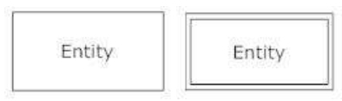

are represented by diamond shapes, show how two entities  
share information in the database. In some cases, entities can be self-linked.  
For example, employees can supervise other employees.

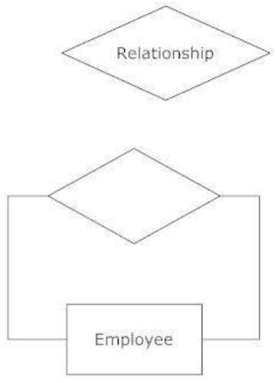

**iii. Attributes**, which are represented by ovals. A key attribute is the unique,  
distinguishing characteristic of the entity. For example, an employee's social  
security number might be the employee's key attribute.

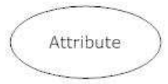

A derived attribute is based on another attribute. For example, an employee's  
monthly salary is based on the employee's annual salary.

**iv. Connecting lines**, solid lines that connect attributes to show the relationships of  
entities in the diagram.  
Cardinality specifies how many instances of an entity relate to one instance of  
another entity. Ordinality is also closely linked to cardinality. While cardinality  
specifies the occurrences of a relationship, ordinality describes the relationship  
as either mandatory or optional. In other words, cardinality specifies the  
maximum number of relationships and ordinality specifies the absolute  
minimum number of relationships.

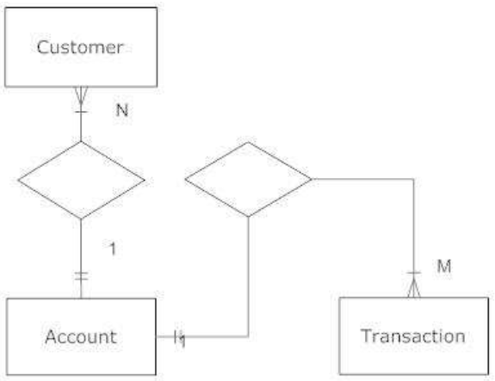

**v.** There are many notation styles that express cardinality:

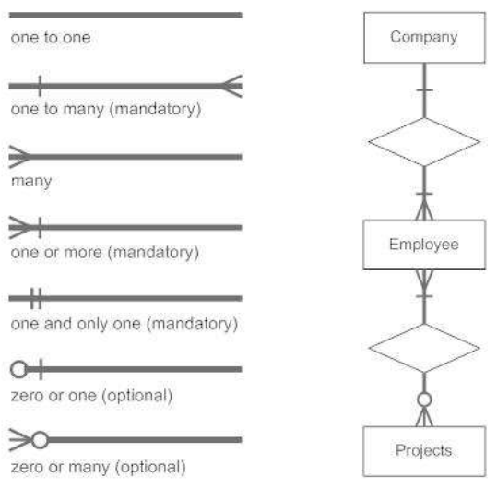

Entity Relationship Diagram Example:

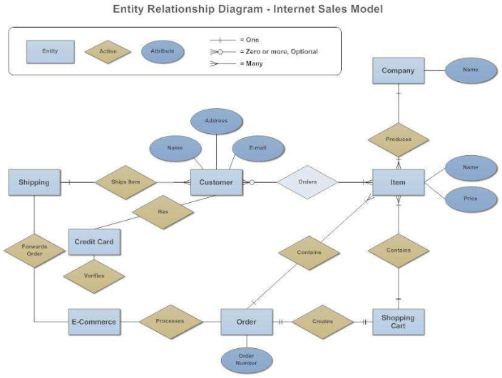

**EXPERIMENT NO. 03**

**AIM:** To find the requirement specification (both functional and nonfunctional) of a given Problem.

### Ans. Step 1:

**Introduction:**

Identify the product whose software requirements are specified in this document. Describe the scope of the product that is covered by this SRS, particularly if this SRS describes only part of the system or a single subsystem. Describe the different types of user that the document is intended for, such as developers, project managers, marketing staff, users, testers, and documentation writers. Describe what the rest of this SRS contains and how it is organized. Suggest a sequence for reading the document, beginning with the overview sections and proceeding through the sections that are most pertinent to each reader type.

### Project Scope

Provide a short description of the software being specified and its purpose, including relevant benefits, objectives, and goals. Relate the software to corporate goals or business strategies. If a separate vision and scope document is available, refer to it rather than duplicating its contents here. An SRS that specifies the next release of an evolving product should contain its own scope statement as a subset of the long-term strategic product vision.

### Step 2:

**Overall Description**

**Product Perspective**

Describe the context and origin of the product being specified in this SRS. For example, state whether this product is a follow-on member of a product family, a replacement for certain existing systems, or a new, self-contained product. If the SRS defines a component of a larger system, relate the requirements of the larger system to the functionality of this software and identify interfaces between the two. A simple diagram that shows the major components of the overall system, subsystem interconnections, and external interfaces can be helpful.

### Product Features

Summarize the major features the product contains or the significant functions that it performs or lets the user perform. Only a high level summary is needed here. Organize the functions to make them understandable to any reader of the SRS. A picture of the major groups of related requirements and how they relate, such as a top level data flow diagram or a class diagram, is often effective.

### User Classes and Characteristics

Identify the various user classes that you anticipate will use this product. User classes may be differentiated based on frequency of use, subset of product functions used, technical expertise, security or privilege levels, educational level, or experience. Describe the pertinent characteristics of each user class. Certain requirements may pertain only to certain user classes. Distinguish the favored user classes from those who are less important to satisfy*.*

### Operating Environment

Describe the environment in which the software will operate, including the hardware platform, operating system and versions, and any other software components or applications with which it must peacefully coexist*.*

### Design and Implementation Constraints

Describe any items or issues that will limit the options available to the developers. These might include: corporate or regulatory policies; hardware limitations (timing requirements, memory requirements); interfaces to other applications; specific technologies, tools, and databases to be used; parallel operations; language requirements; communications protocols; security considerations; design conventions or programming standards (for example, if the customer’s organization will be responsible for maintaining the delivered software).

### Step 3:

**System Features**

This template illustrates organizing the functional requirements for the product by system features, the major services provided by the product. You may prefer to organize this section by use case, mode of operation, user class, object class, functional hierarchy, or combinations of these, whatever makes the most logical sense for your product.

### System Feature 1

Don’t really say “System Feature 1.” State the feature name in just a few words.

**Description and Priority**

Provide a short description of the feature and indicate whether it is of High, Medium, or Low priority. You could also include specific priority component ratings, such as benefit, penalty, cost, and risk (each rated on a relative scale from a low of 1 to a high of 9).

**Stimulus/Response Sequences**

List the sequences of user actions and system responses that stimulate the behavior defined for this feature. These will correspond to the dialog elements associated with use cases.

**Functional Requirements**

Itemize the detailed functional requirements associated with this feature. These are the software capabilities that must be present in order for the user to carry out the services provided by the feature, or to execute the use case. Include how the product should respond to anticipated error conditions or invalid inputs. Requirements should be concise, complete, unambiguous, verifiable, and necessary.

*<Each requirement should be uniquely identified with a sequence number or a meaningful tag of some kind.>*

REQ-1:

REQ-2:

### Step 4:

**External Interface Requirements User Interfaces**

Describe the logical characteristics of each interface between the software product and the users. This may include sample screen images, any GUI standards or product family style guides that are to be followed, screen layout constraints, standard buttons and functions (e.g., help) that will appear on every screen, keyboard shortcuts, error message display standards, and so on. Define the software components for which a user interface is needed. Details of the user interface design should be documented in a separate user interface specification.

### Hardware Interfaces

Describe the logical and physical characteristics of each interface between the software product and the hardware components of the system. This may include the supported device types, the nature of the data and control interactions between the software and the hardware, and communication protocols to be used.

### Software Interfaces

Describe the connections between this product and other specific software components (name and version), including databases, operating systems, tools, libraries, and integrated commercial components. Identify the data items or messages coming into the system and going out and describe the purpose of each. Describe the services needed and the nature of communications. Refer to documents that describe detailed application programming interface protocols. Identify data that will be shared across software components. If the data sharing mechanism must be implemented in a specific way (for example, use of a global data area in a multitasking operating system), specify this as an implementation constraint.

### Communications Interfaces

Describe the requirements associated with any communications functions required by this product, including e-mail, web browser, network server communications protocols, electronic forms, and so on. Define any pertinent message formatting. Identify any communication standards that will be used, such as FTP or HTTP. Specify any communication security or encryption issues, data transfer rates, and synchronization mechanisms

### Non functional Requiremnt

### Performance Requirements

If there are performance requirements for the product under various circumstances, state them here and explain their rationale, to help the developers understand the intent and make suitable design choices. Specify the timing relationships for real time systems. Make such requirements as specific as possible. You may need to state performance requirements for individual functional requirements or features.

### Safety Requirements

Specify those requirements that are concerned with possible loss, damage, or harm that could result from the use of the product. Define any safeguards or actions that must be taken, as well as actions that must be prevented. Refer to any external policies or regulations that state safety issues that affect the product’s design or use. Define any safety certifications that must be satisfied.

### Security Requirements

Specify any requirements regarding security or privacy issues surrounding use of the product or protection of the data used or created by the product. Define any user identity authentication requirements. Refer to any external policies or regulations containing security issues that affect the product. Define any security or privacy certifications that must be satisfied.

### Software Quality Attributes

Specify any additional quality characteristics for the product that will be important to either the customers or the developers. Some to consider are: adaptability, availability, correctness, flexibility, interoperability, maintainability, portability, reliability, reusability, robustness, testability, and usability. Write these to be specific, quantitative, and verifiable when possible. At the least, clarify the relative preferences for various attributes, such as ease of use over ease of learning.

### Other Requirements

Define any other requirements not covered elsewhere in the SRS. This might include database requirements, internationalization requirements, legal requirements, reuse objectives for the project, and so on. Add any new sections that are pertinent to the project.